# Day 5 - Testing and Backend Refinement - Hekto Web

# Testing Report

|  |  |  |  |  |
| --- | --- | --- | --- | --- |
| **Test Case ID** | **Description** | **Status** | **Security Level** | **Remarks** |
| TC001 | Validate Product Listing Page | Passed | Low | Displayed Perfectly. |
| TC002 | Test API Error Handling | Passed | Low | Displayed Successfully. |
| TC003 | Check Cart Functionality | Passed | Medium | Works as expected. |
| TC004 | Validate Search Bar | Passed | High | Expected Work. |
| TC005 | Validate Dynamic Product Details | Passed | Low | Displayed Successfully. |
| TC006 | Cross Browsing | Passed | Low | Successful. |
| TC007 | Ensure Responsiveness on Mobile/Tablet | Passed | Medium | Tested Successfully. |

### Details of Individual Test Cases

#### Test Case: TC001 - Validate Product Listing Page

**Test Steps:**

1. Open the Product Listing Page.
2. Validate that all products are displayed correctly.

**Expected Result:** All products should load and display successfully.

**Actual Result:** Products displayed perfectly without issues.

**Status:** Passed

**Security Level:** Low

**Remarks:** Displayed Perfectly.

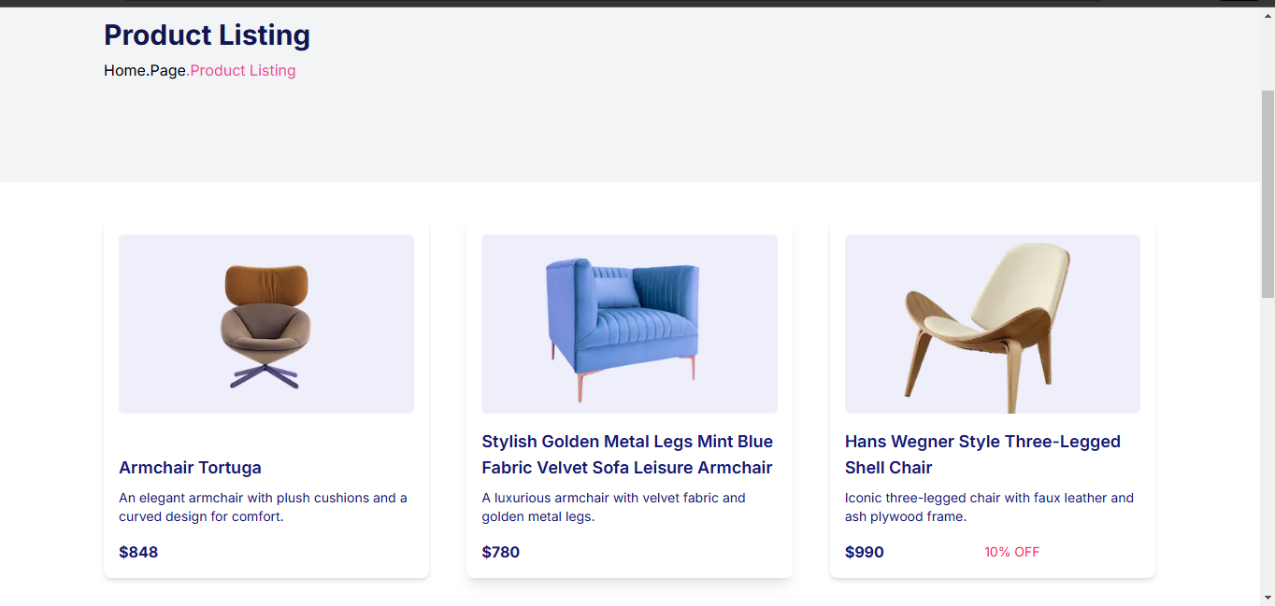

#### Test Case: TC002 - Test API Error Handling

**Test Steps:**

1. Disconnect Qroq Query intentionally.
2. Refresh the page.

**Expected Result:** Error message should be displayed clearly on the screen.

**Actual Result:** Error message displayed successfully.

**Status:** Passed

**Security Level:** Low

**Remarks:** Displayed Successfully.

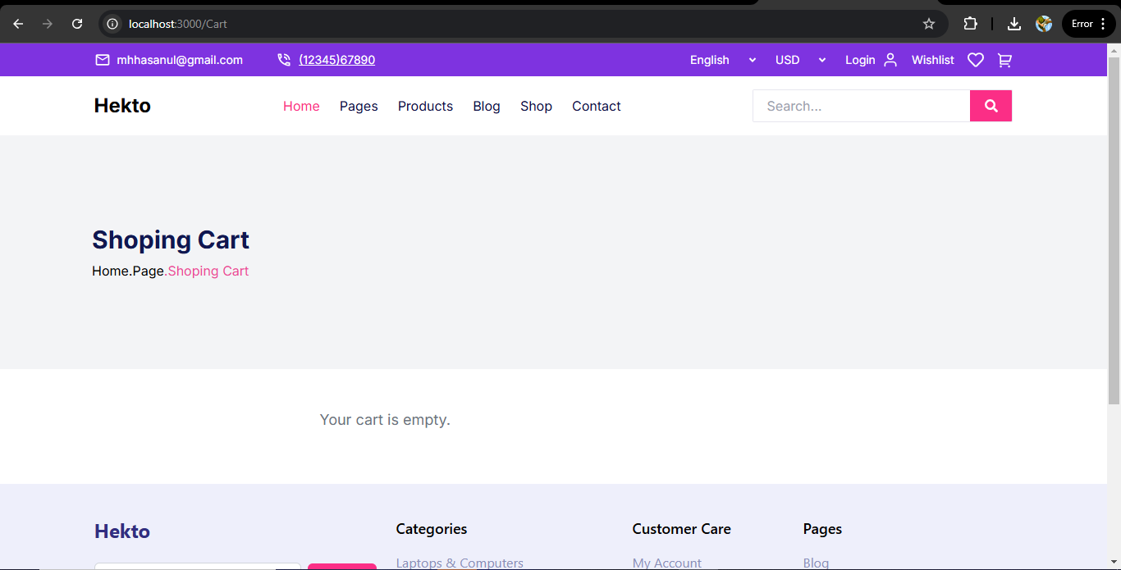

#### Test Case: TC003 - Check Cart Functionality

**Test Steps:**

1. Add items to the cart.
2. Verify the cart contents.

**Expected Result:** Cart should update with the added products.

**Actual Result:** Cart updated as expected.

**Status:** Passed

**Security Level:** Medium

**Remarks:** Works as expected

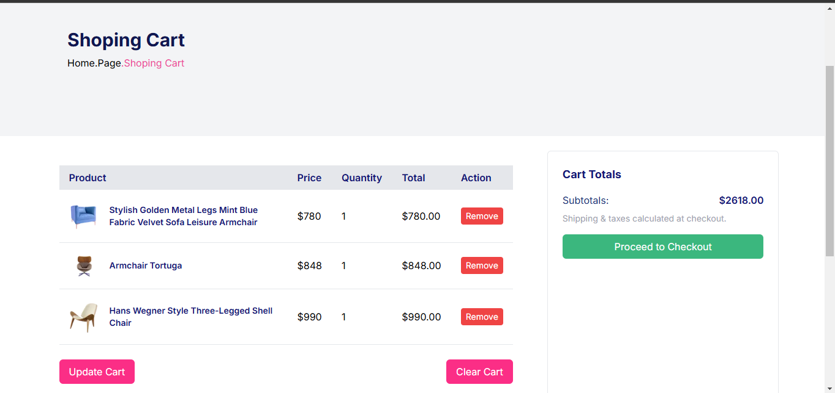

#### Test Case: TC004 - Validate Search Bar

**Test Steps:**

1. Enter items in the search bar that are not in the Sanity database.
2. Observe the dropdown.

**Expected Result:** Dropdown should show “No product Found.”

**Actual Result:** Dropdown not showing during search.

**Status:** Passed

**Security Level:** High

**Remarks:** Expected Work

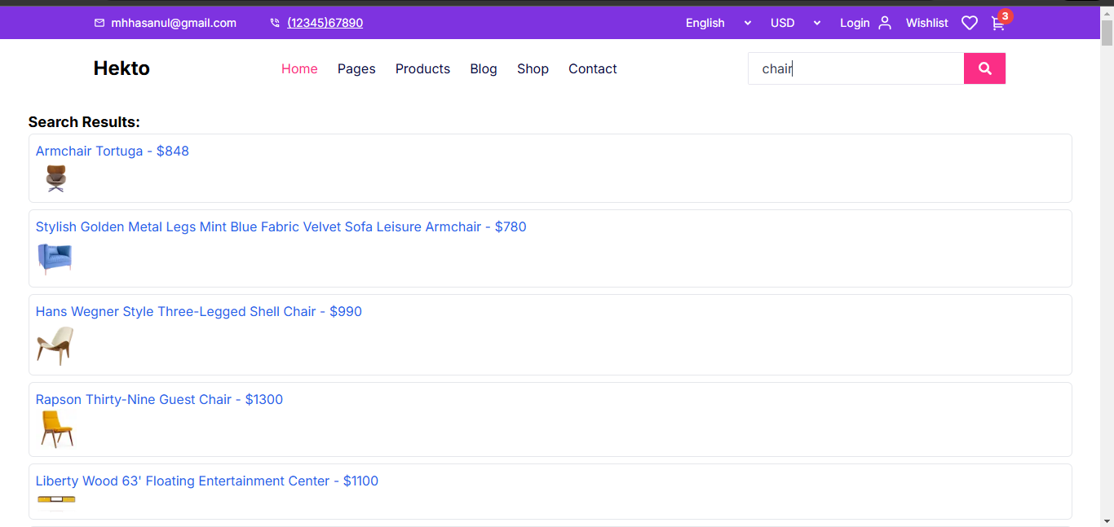

#### Test Case: TC005 - Validate Dynamic Product Details

**Test Steps:**

1. Open the product page.
2. Click on any product card.

**Expected Result:** Dynamic detailed product page should open.

**Actual Result:** Dynamic detailed product page opened successfully.

**Status:** Passed

**Security Level:** Low

**Remarks:** Displayed Successfully.

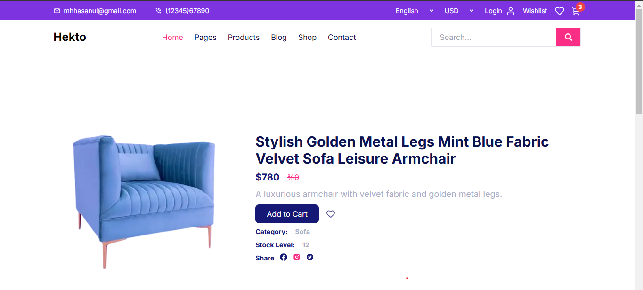

#### Test Case: TC006 - Cross Browsing

**Test Steps:**

1. Open the website on multiple browsers (e.g., Chrome, Firefox, Edge).

**Expected Result:** Website should work correctly on every browser.

**Actual Result:** Functionality is consistent across all browsers.

**Status:** Passed

**Security Level:** Low

**Remarks:** Successful.

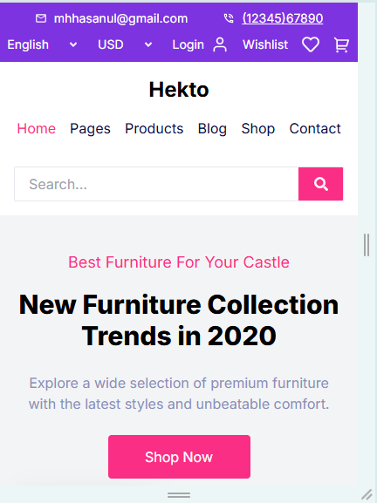

#### Test Case: TC007 - Ensure Responsiveness on Mobile/Tablet

**Test Steps:**

1. Resize the browser window to simulate mobile and tablet screen sizes.

**Expected Result:** Layout should adjust properly according to screen size.

**Actual Result:** Responsive layout works as intended.

**Status:** Passed

**Security Level:** Medium

**Remarks:** Tested Successfully.